Vargha Hokmran, Nick Hanley, Christopher Feener

Professor Zhao

CS-320

10.27.2016

Software Design Document

**Architectural Design**

Input device

Input device

Output Device

Output Device

Network

TicTacToe

TicTacToe

**Data Design**

No input data involved

**Activity Diagrams**

Chat Dialog

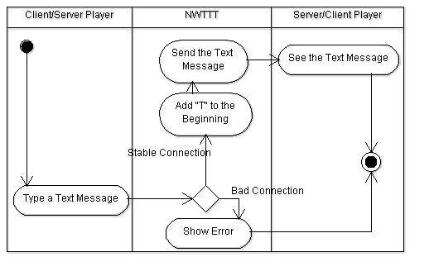

Single Player Game Mode

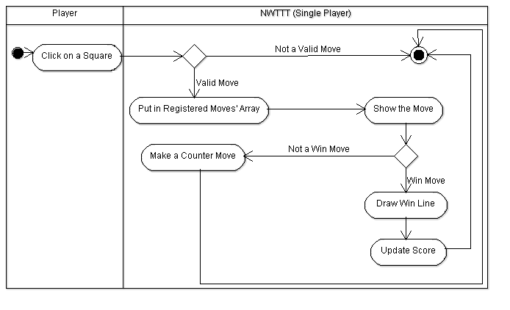

Two Player Game Mode

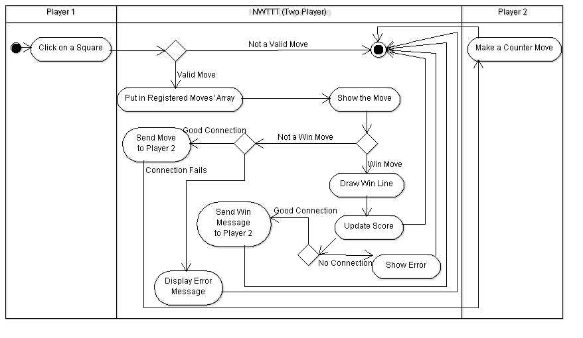

**Structural Modeling / Class Diagrams**

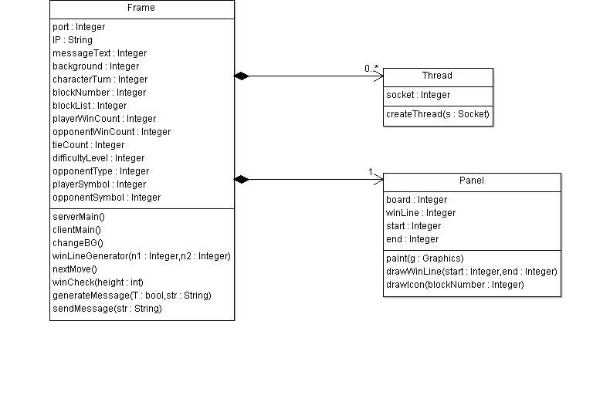

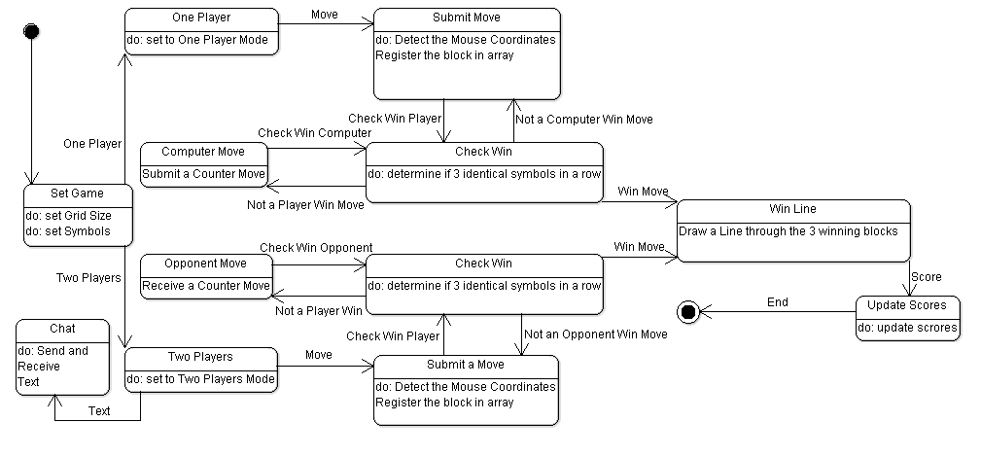**Behavior Modeling / State Diagram**